PPG NewsLetter
Autumn/Winter 2018: Edition 8

Seasonal Greetings
To All

Friday 21st December: 8.00 – 6.30pm
Saturday 22nd December: Closed
Sunday 23rd December: Closed
Monday 24th December: 8.00 – 6.30pm
Tuesday 25th December: Closed
Wednesday 26th December: Closed
Thursday 27th December: 8.00-6.30pm
Friday 28th December: 8.00-6.30pm
Saturday 29th December: Closed
Sunday 30th December: Closed
Monday 31st January: 8.00-6.30pm Tuesday 1st January: Closed
Wednesday 2nd January: 8.00 – 6.30pm
The benefits of using Patient Access: -
- Everything is done on line via a computer or a mobile app
- Your repeat prescription can be ordered online so that it is ready for you to pick up from the surgery or you can ask for it to be sent straight to a pharmacy of your choice
- You can pre book on line appointments- non urgent
- Message the GP with health issues - non urgent
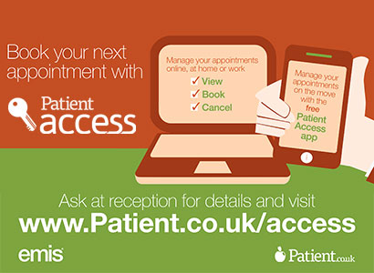
- View some of your medical notes on line

To sign up for Patient Access please contact reception and they will give you the relevant forms and more information.
Important notice to all patients:
Please make sure that you keep all your details up to date
These include:
* Phone Number
* Address if you move house
* Email address if appropriate
* Change of name
* Anything else you think the practice may need to know
You will be required to produce identification for a change of address such as a recent utility bill at your new address

SEASONAL FLU
Flu (also known as influenza) is a highly infectious illness caused by the flu virus. It spreads rapidly through small droplets coughed or sneezed into the air by an infected person.

For most people, flu is unpleasant but not serious. You will usually recover within a week. Studies have shown that flu vaccines provide effective protection against the flu, although protection on may not be complete and may vary between people. Protection from the vaccine gradually decreases and flu strains change over time. Therefore, new vaccines are made each year and people at risk of flu are encouraged to be vaccinated every year.
Who should have the flu jab?
The injected flu vaccine is offered free of charge on the NHS to people who are at risk. You are eligible to receive a free u jab if you:
- Are 65 years of age or over
- Are pregnant
- Have certain medical conditions
- Are very overweight
- Are living in a long-stay residential care home or other long-stay care facility
- Receive a carer’s allowance, or you are the main carer for an elderly or disabled person
- Are a healthcare worker with direct patient contact, or a social care worker
APPOINTMENT SITUATION
Demand for appointments has escalated to an unprecedented high level. So please help me to help you by sharing the reason for your call with the reception team. This will avoid you from having to call back again and again for an appointment. If you share the reasons then you will be guaranteed treatment on the same day!

Introducing Walking Football  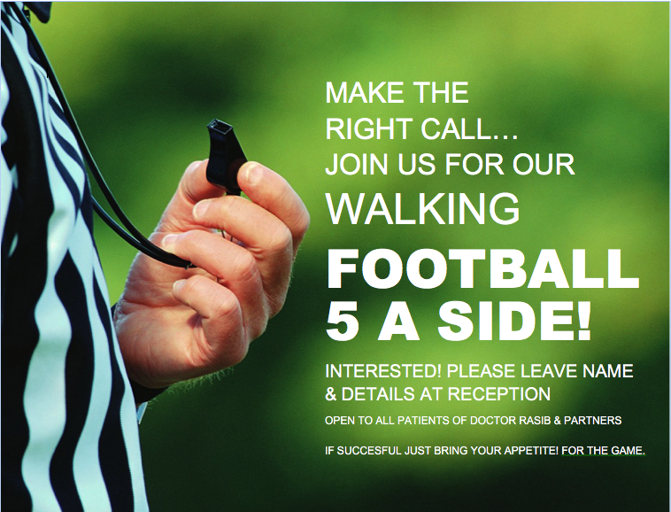  Please get involved  PATIENT QUESTIONNAIRES  Please get involved with the patient surveys which will be handed out by our PPG members between September – December – it is important that we hear and receive feedback from our patients  Health & Wellbeing  Just give a thought!  Enjoy your celebrations through the festive season, the food and drink you will enjoy, just give the same thought to your care of health and wellbeing.  FLU & PNEUMO VACCINATIONS  FLU JAB! Don’t Come Down With The Flu, Come Down Here For The Flu JAB!  PLEASE BOOK AT RECEPTION  PPG (PATIENT PARTICIPATION GROUP)  Our PPG continues to be a valuable source of information and support for the Practice team.  The next meeting will be held on Wednesday 13th December at 1.00pm at the Practice. If you are interested in joining the PPG, please speak to the reception team. | Emergency & OOH Cover  EMERGENCIES  In the event of a serious problem, such as chest pain or collapse, call 999 immediately.  OUT-OF-HOURS COVER  Medical advice is always available for emergencies at night, weekends and  all bank holidays.  NHS 111  For urgent  & non-urgent advice call 111.  You can also ring  01543 576660  where the recorded message will give you the number for the Out-of-Hours service  STOP PRESS!  DO NOT FORGET THAT WE OFFER TELEPHONE CONSULTATIONS  Thursday evenings  6.30-7.30pm
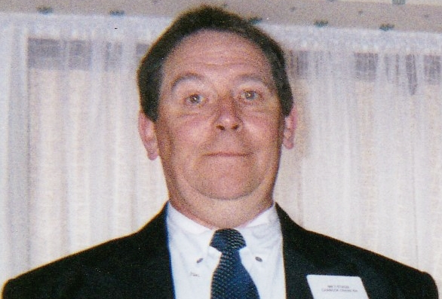
Dear Patient.

To give you a short view of group works from August to April.
First along with management format the questions for annual Patient Questionnaire,
Middle of September group members give time voluntary to distribute and collect filled questionnaires, up to middle of December.

In the month of February group members collate the results of the questionnaire in preparation to handover total replies to management in March.

By April we have formed an action plan which will be monitored also if any changes have been made as well, from what you have informed us of through Patient Questionnaire, so important for us all. Thank you for your time.

Flu vaccine is for the prevention of Influenza.
When you next visit for a consultation ask at reception if your eligible for a flu injection as its for your health and welfare.

I have found the flu injections does not give you a bout of the flu, It’s a myth.

Please if you have a interest in any of the PPG work or wish to know more, or join, application forms are to the right side of the PPG Noticeboard, or email

(staggdavid@hotmail.com)

Yours Faithfully David Stagg, PPG Chairman.

Message
PPG Chairman

Disclaimer: This newsletter is produced by the PPG group in partnership with the practice management team. Some articles written by PPG members are of their ideas, facts or opinions and therefore will not be the responsibility of the surgery. If you have any queries then please fell free to contact the PPG Chairman, David Stagg by phone: 07549 021316

‘SEASONAL NEW YEAR GREETINGS TO ALL’

If you require this leaflet in any other format then please do not hesitate to speak to a member of the team.

If you have any comments or suggestions about this newsletter or indeed any aspect of the service that Dr Rasib & Partners provides, please feel free to contact the Managing Partner, Sam Rasib on 01543 576660 or in writing to GP Suite, Cannock Chase Hospital, Brunswick Road, WS11 5XY

